BACKPACK ORDER FORM

SWIMMER’S NAME:__________________________________

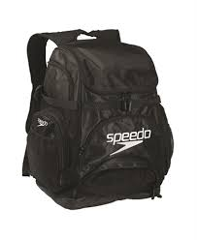
BACKPACK
$43.00
$21.50 (New Swimmer Discount)

EMBROIDERY
$12.00
$6.00 (New Swimmer Discount)

______________________________________
(Print the swimmer’s first or last name as you wish it to appear on the backpack )

Total $__________ Check # _______ or Cash

*Please have your money to Coach Stelzer by Wednesday, October 14th to ensure your swimmer has his/her backpack before swim meets begin. Make checks payable to OSTBC.

*New Swimmers only: You will pay half ($21.50 for the backpack, $6.00 for embroidery if you choose). The booster club will pay the other half.
*Veteran Swimmers: This is totally voluntary. You only need to order if your swimmer wants a new backpack.

